## Lecture 3:

**OOP**: object-oriented programing **OOD**: object-oriented Design

To create a class function outside the class

Return type class name::function name(parameters) { function body }

**Default constructor:** receives no parameters (will be automatically created but you cannot see it and it does not do anything)

**Parametrized constructor:** receives parameters

**Copy constructors:** copies an object to another object that belongs to the same class

**Shallow:** changes in one object will affect the copied object (tightly coupled) (created automatically )

Has no specific syntax

**Deep:** changes in one object will not affect the copied object (user defined)

Has a specific syntax 🡪 ClassName (const ClassName & object) {functions to copy attributes}

Ex: Point(const Point &p1) {x = p1.x; y = p1.y; }

both have the same way of calling in the main 🡪 c2 = c1;

**Destructor:** a function at the end of the class (created automatically) 🡪 ~class name();

## Lecture 4:

**Abstract data type (ADT):** a class that has a defined set of operations and values

Same code can be used multiple times ex: #include<iostream> / #include<header.h>

**Separate compilation:** each part of the code is stored in a separate file

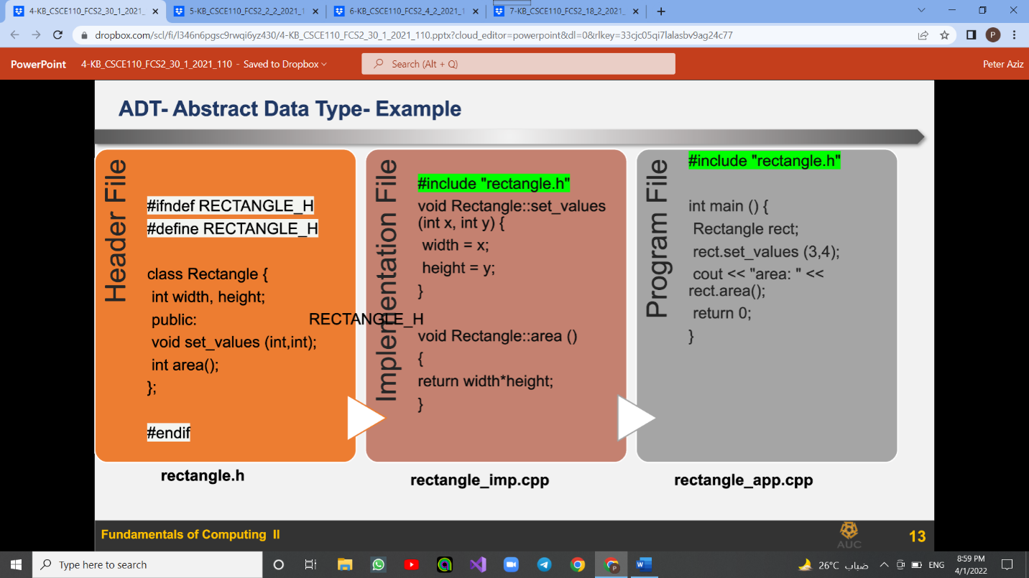

**In the header:** add class members and the names of the functions

**In the implementation file:** we add the actual functions

**Program/application/driver file:** we add the main function

Use a token when using the header file multiple times to define the class once

#ifndef header_file_name

#define header_file_name

#endif

**Generic programing:** the idea of allowing different data types to work in the same function

Benefits: code reusability / avoid function overloading

To create a template function (function that takes different data types)

template<class T>​

void swap_values(T& v1 , T& v2){

T temp;

Temp= v1;

V1 = v2;

V =temp;

}

To refer to the class afterwards: class name<T> ex: node<T> * next node<T>::delete();

**Stack:** first in last out (has a top)

Functions:

* push(e): inserts an element e to the top of the stack​
* pop(): removes and returns the top element of the stack​
* top(): returns a reference to the top element of the stack, but doesn’t remove​
* size(): returns the number of elements in the stack
* empty(): returns a bool indicating if the stack contains any objects

**Queue:** first in first out (has a rear and a front)

## Lecture 5:

**Inheritance:**

Class A (parent – base – superclass) ----> class B (child – derived - subclass)

Members that get inherited: public and protected (never private)

Types of inheritance: public – protected – private

Public: public and protected will remain the same

Protected: public and protected members will be protected

Private: public and protected members will be private

Default inheritance is private

Syntax 🡪 class derived_class_name : inheritance_type base_class_name

ex: class HourlyEmployee : public Employee​

A base class constructor, destructors and assignmentoperator (+ - * /) are not inherited in a ​derived class

**Polymorphism:**

Function overloading: multiple functions with the same name but different attributes (compile time) (early binding) (static binding)

Operator overriding: overriding methods of base class in child class (run time) (late binding) (dynamic binding)

Syntax: add virtual before the function in the base class and leave it empty

Create a pointer of base class, create an object of child class, make pointer point to child class

Ex: Animals *a; ​Cats c; a= &c; ​

To overload built in operators (+ - * /)

Class_name operator=(const class_name & object ) { class_name oject // fuctions return object}

ex: Box operator+(const Box& b) {​

         Box box; box.length = length + b.length; return box;​ }

Binding refers to the process of converting identifiers (such as variable) into addresses

Pure virtual function: a function with no implementation only declaration

## Lecture 6:

Unified Modeling Language (UML) is a general purpose modelling language.

Always point towards the main class

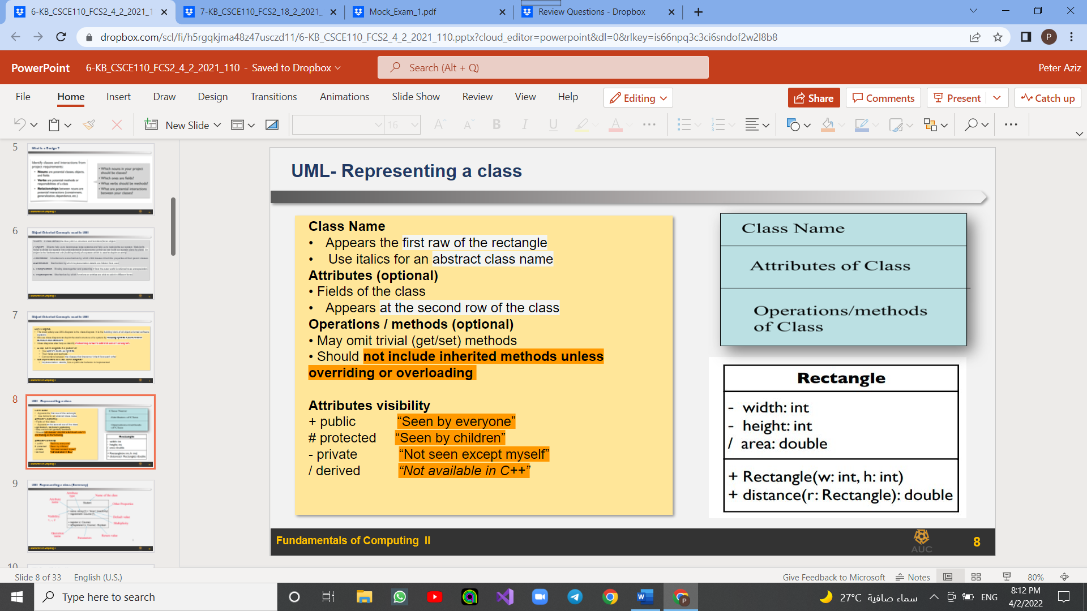

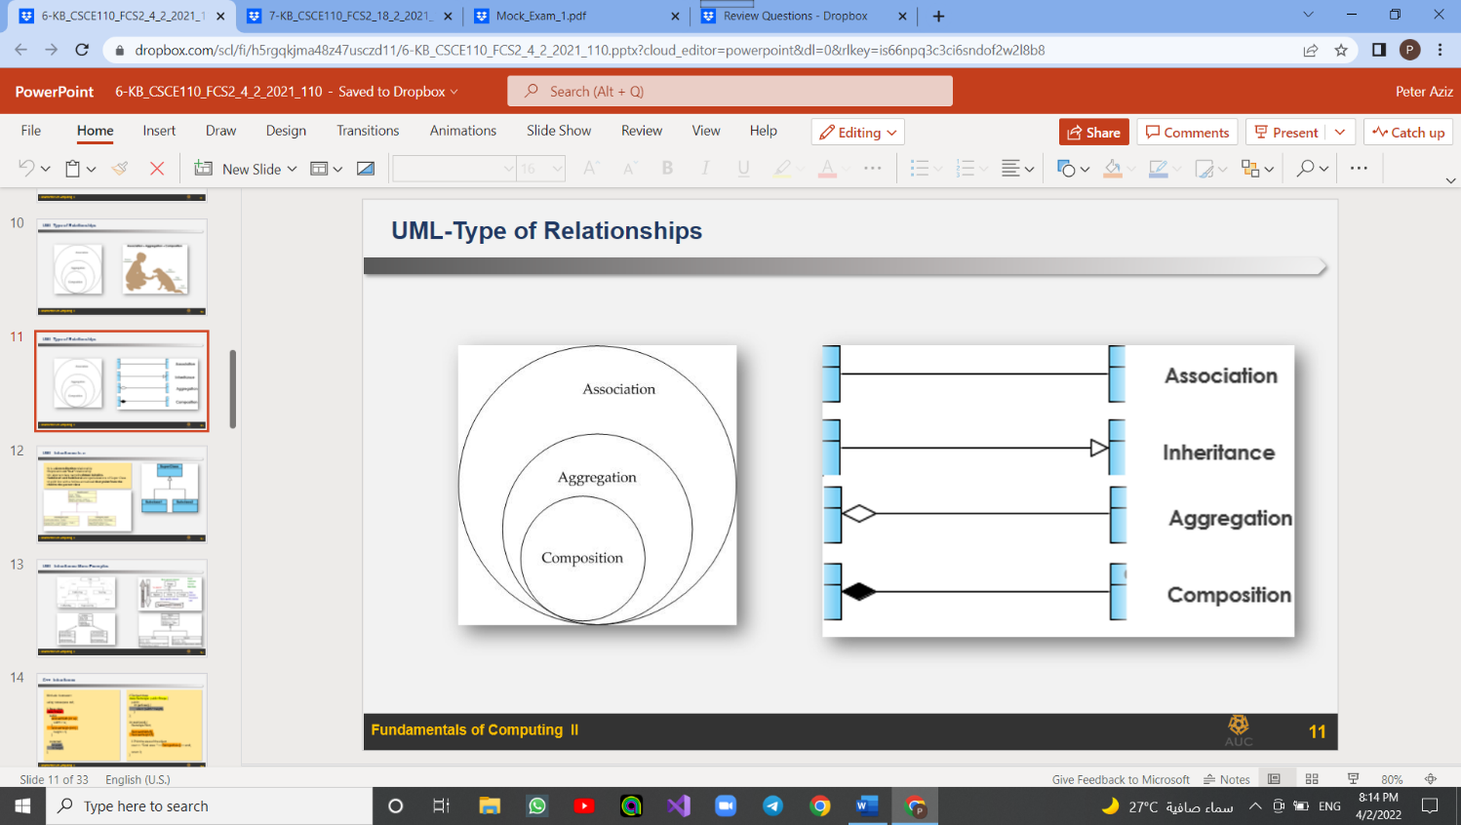

Association: when two classes are linked (uses or has-a)

Inheritance(generalization): base and child class (is a)

An aggregation: whole-part relationship between an aggregate, where the part can exist independently

A composition indicates a strong ownership and coincident lifetime of parts by the whole

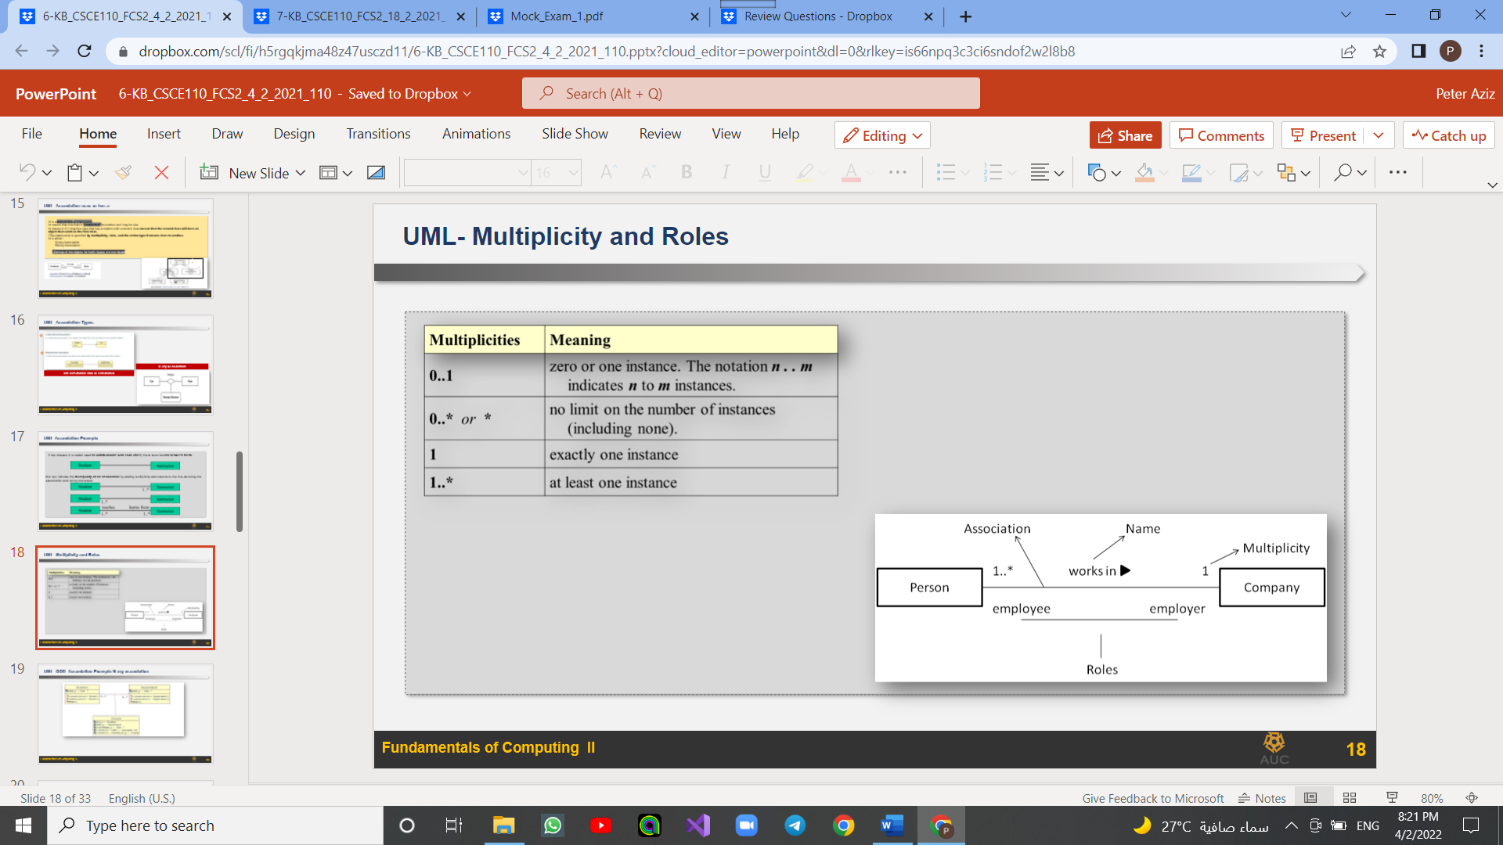Instances:

## Lecture 7:

Time complexity estimates the time to run an algorithm

Big O notation is a way to describe the speed or complexity of a given algorithm. ​

When calculating O, ignore small numbers ex: x^3 + x + 2 --> x^3

Refer to the worst case

**Without recursion**

Whenever you have two for loops in each other complexity is n^2

Bubble sort: best case O(n) - worst/average O(n^2)

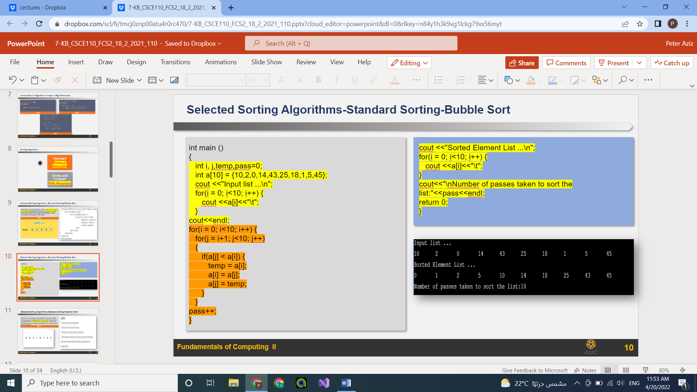

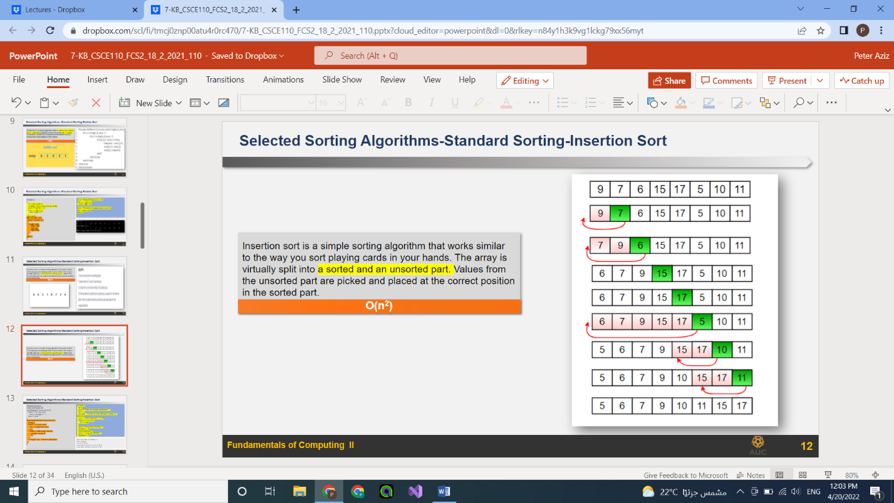Insertion sort: best case O(n) - worst/average O(n^2)

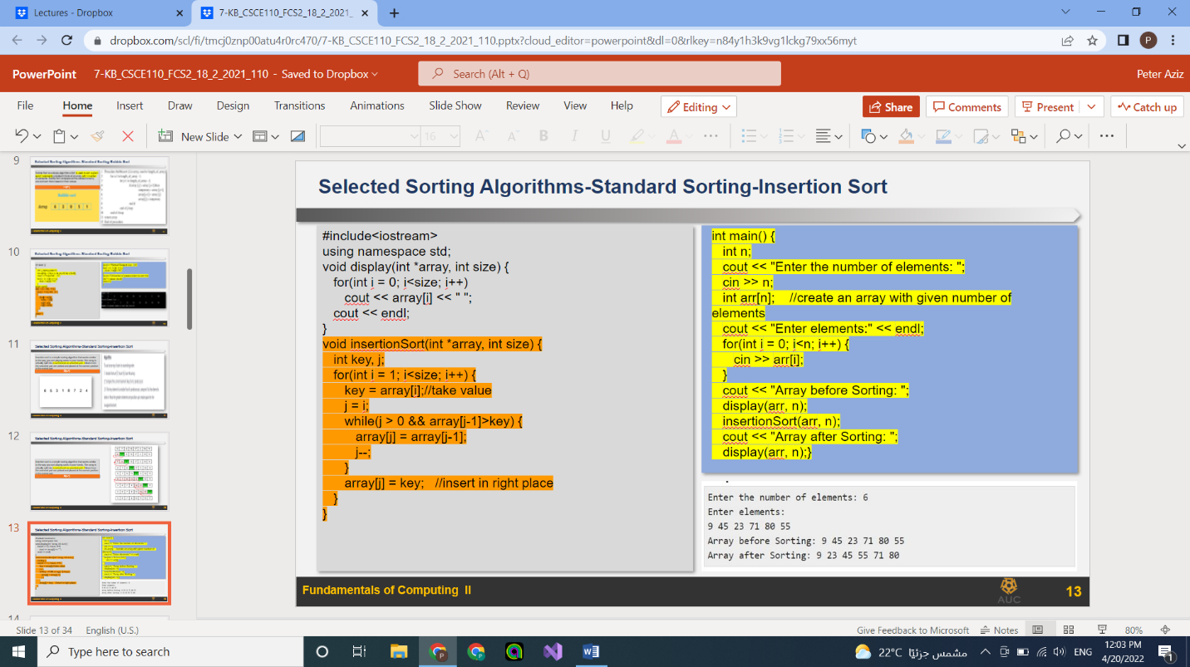

Selection sort: best case O(n) - worst/average O(n^2)

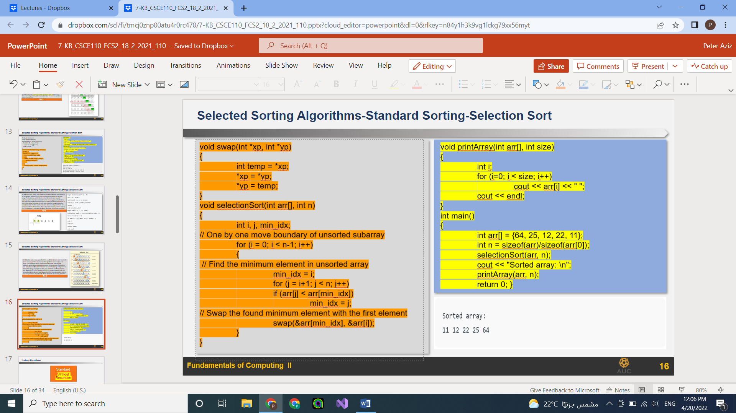

**With recursion**

**Quick sort:** best/ avg. time complexity (n*log n) worst (n^2)

Binary Insertion sort: - worst case (n* log(n))

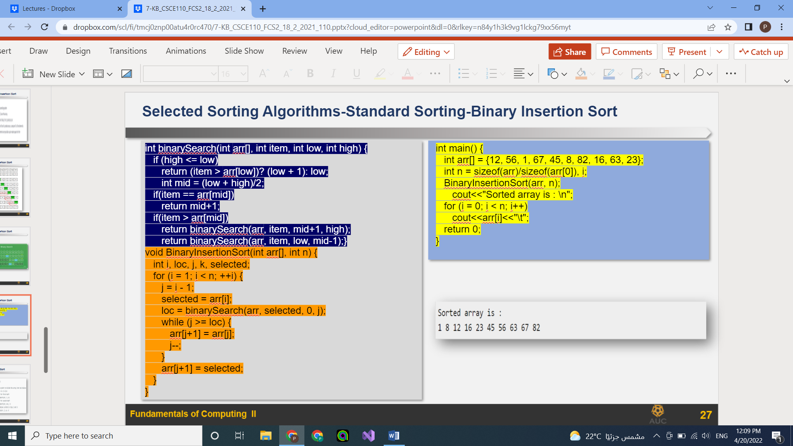

Merge sort: for all cases O (n*log n)

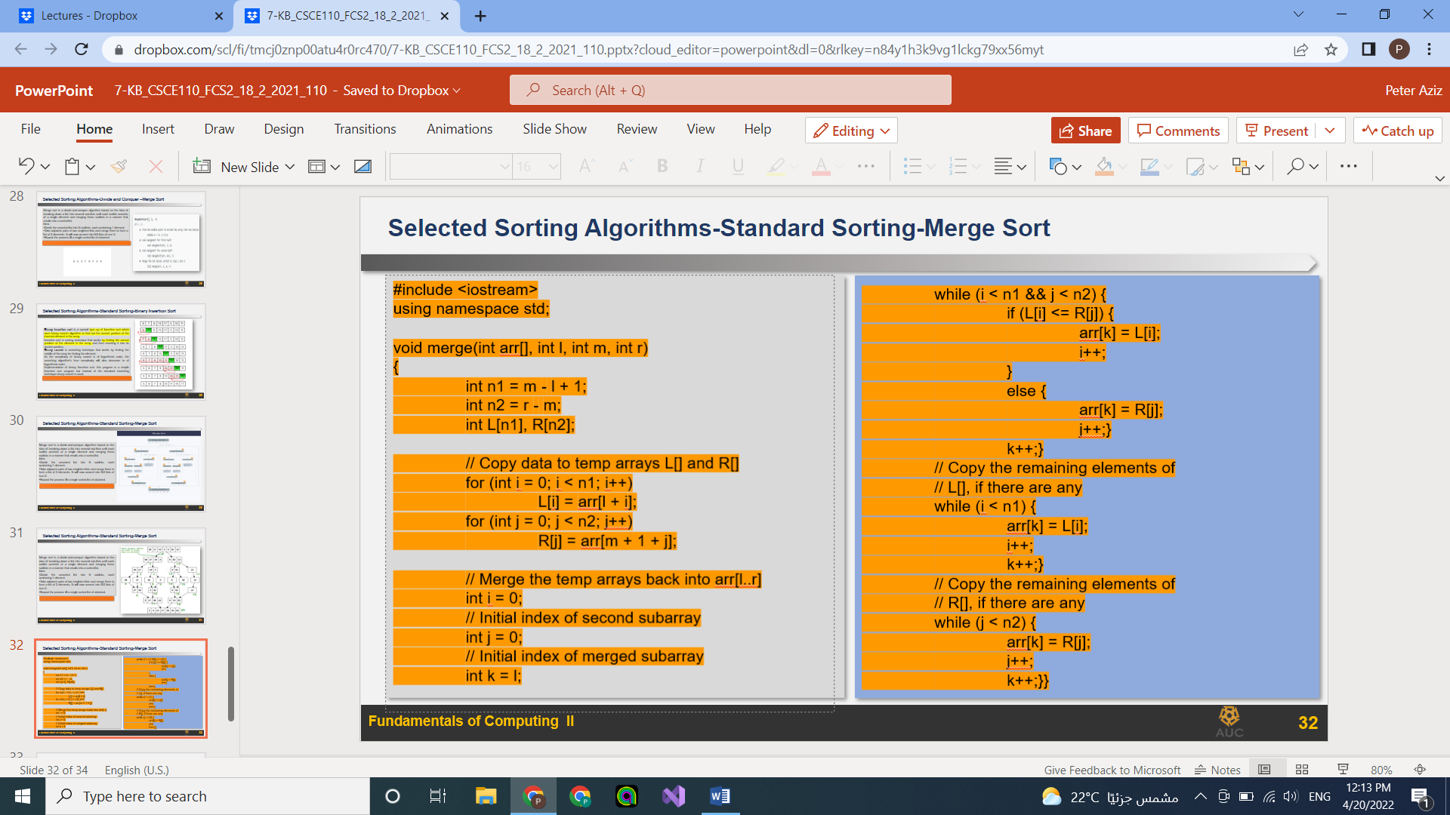

## Lecture 8:

Arrays are homogenous (can only store one type of elements)

Structures (struct) are heterogeneous (can only store different types of elements)

Individual components of a struct type are called members (or fields)

Use (**.**) to use non-pointer objects use (**->**) to use pointers objects

linked list is a structure that consists of 2 parts (the element in the structure which are homogenous) (a pointer to the next element) and it has a head (first element) and a tail (last element)

linked lists are not stored in contiguous memory locations

linked lists:

single: you can move in one direction only

doubly: you can move in both directions

doubly circular: like double but you can move from the last element to the first element directly

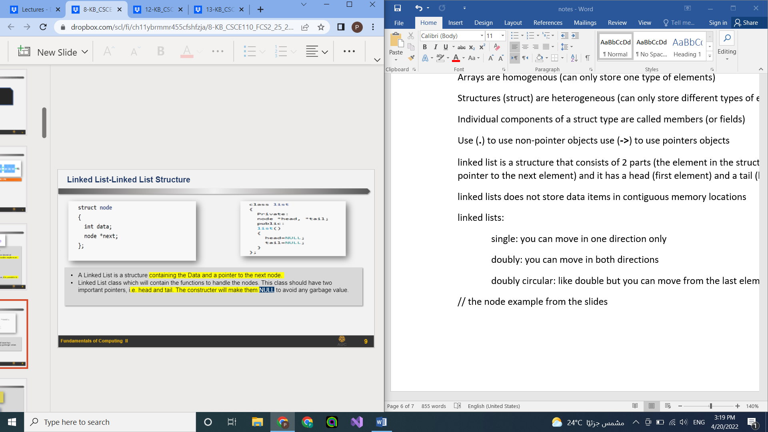

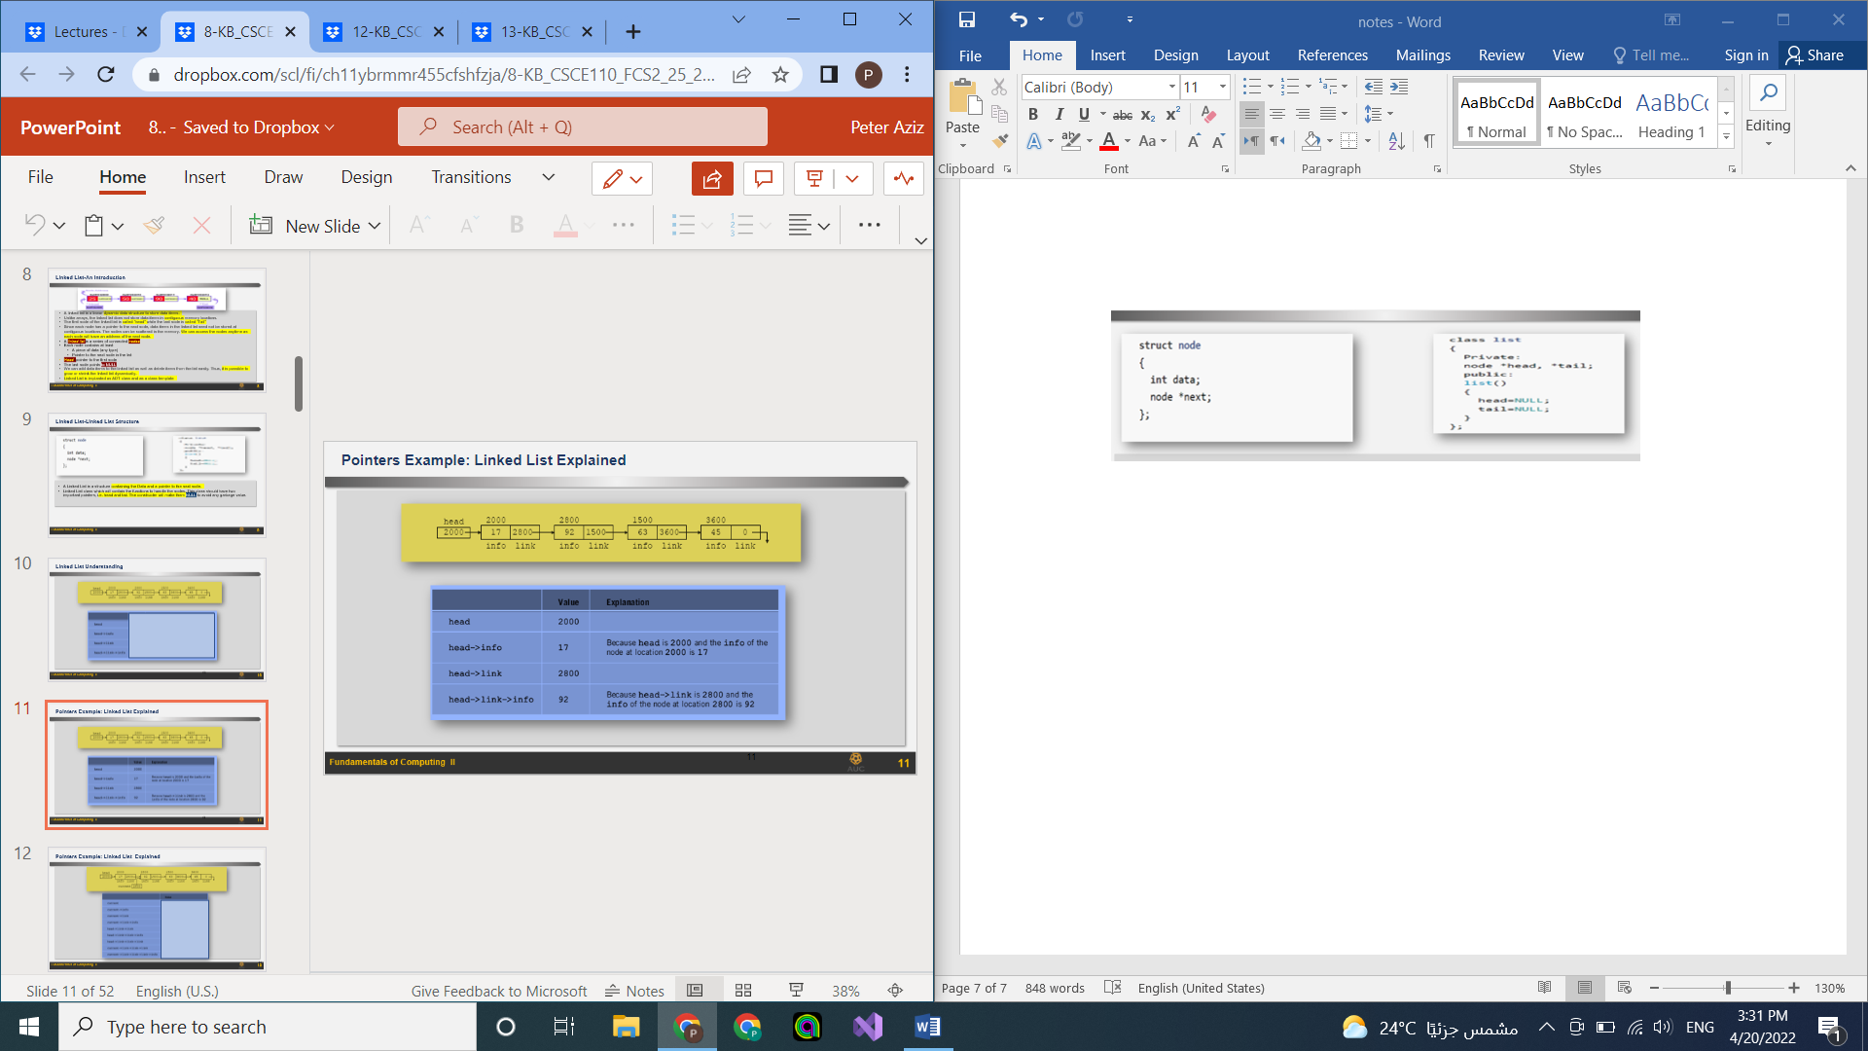

To insert a node at the begging of the list

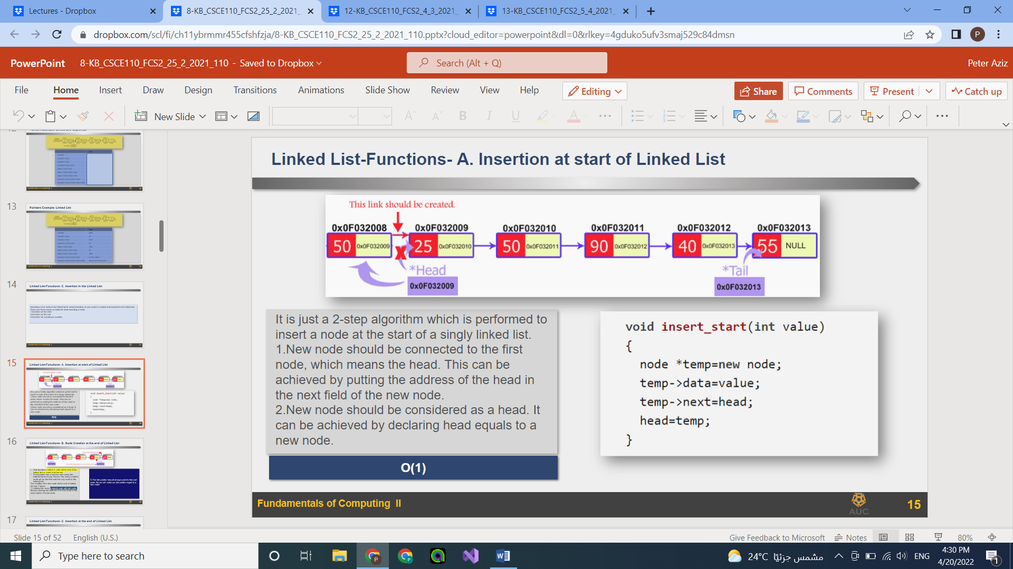

To insert a node at the end of the list

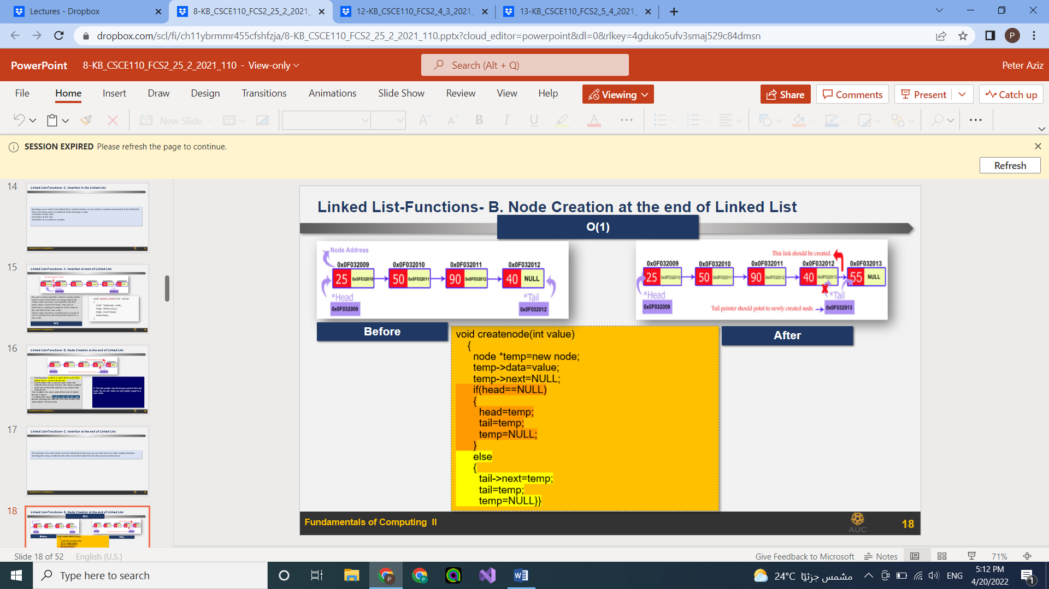

To insert a node at a certain location of the list

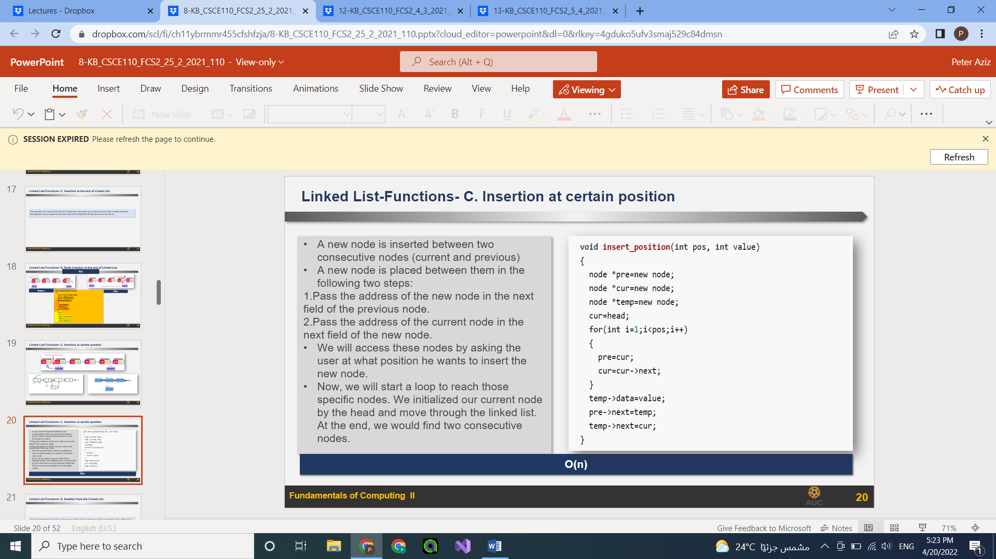

To delete from the begging of a list

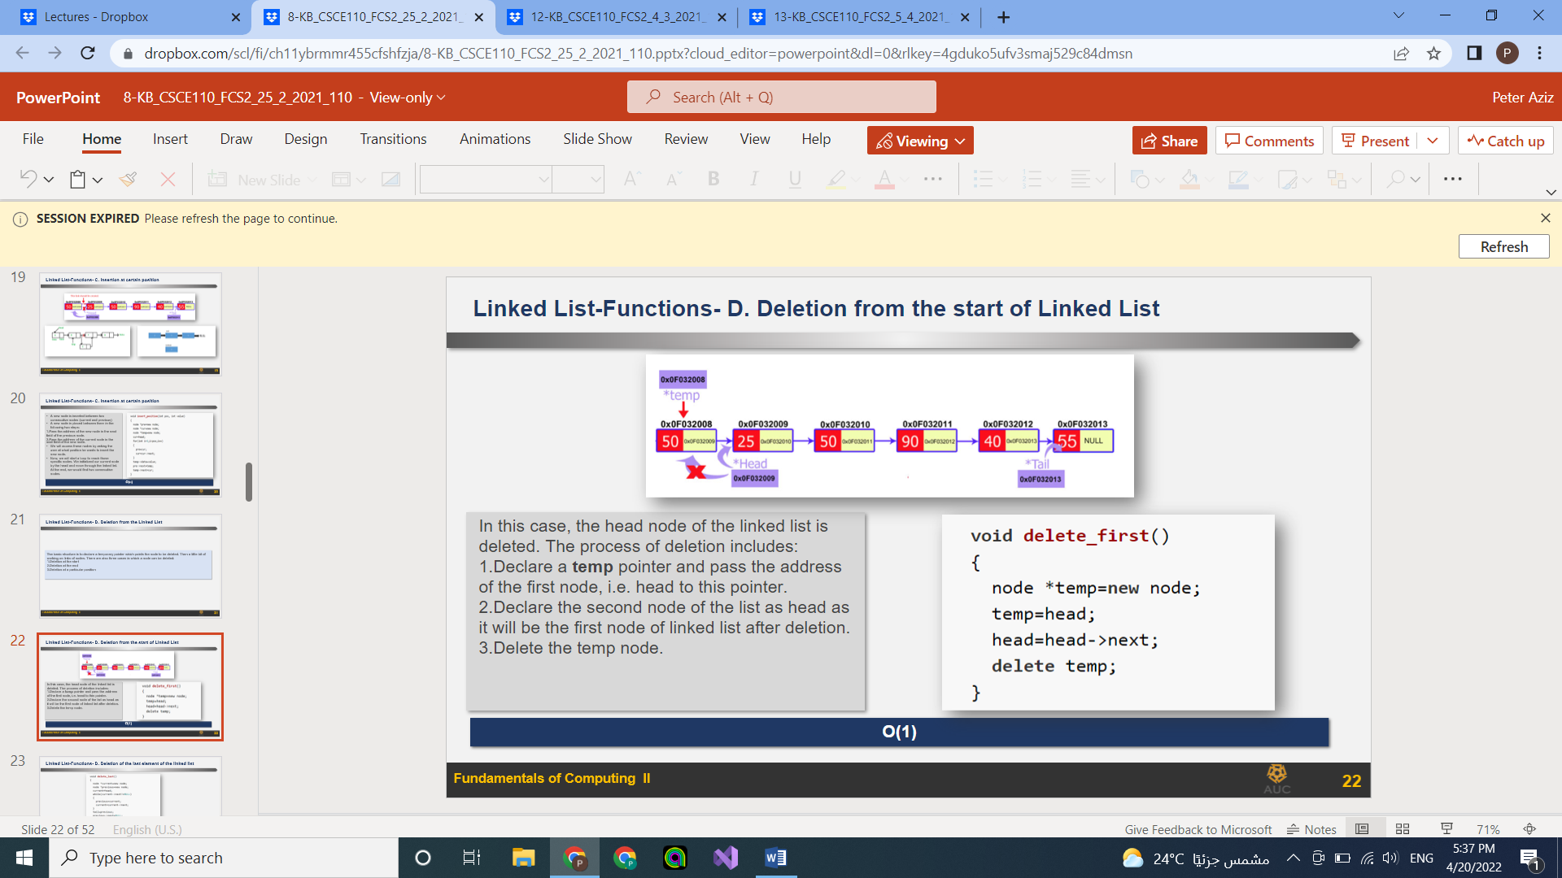

To delete from the end of the list

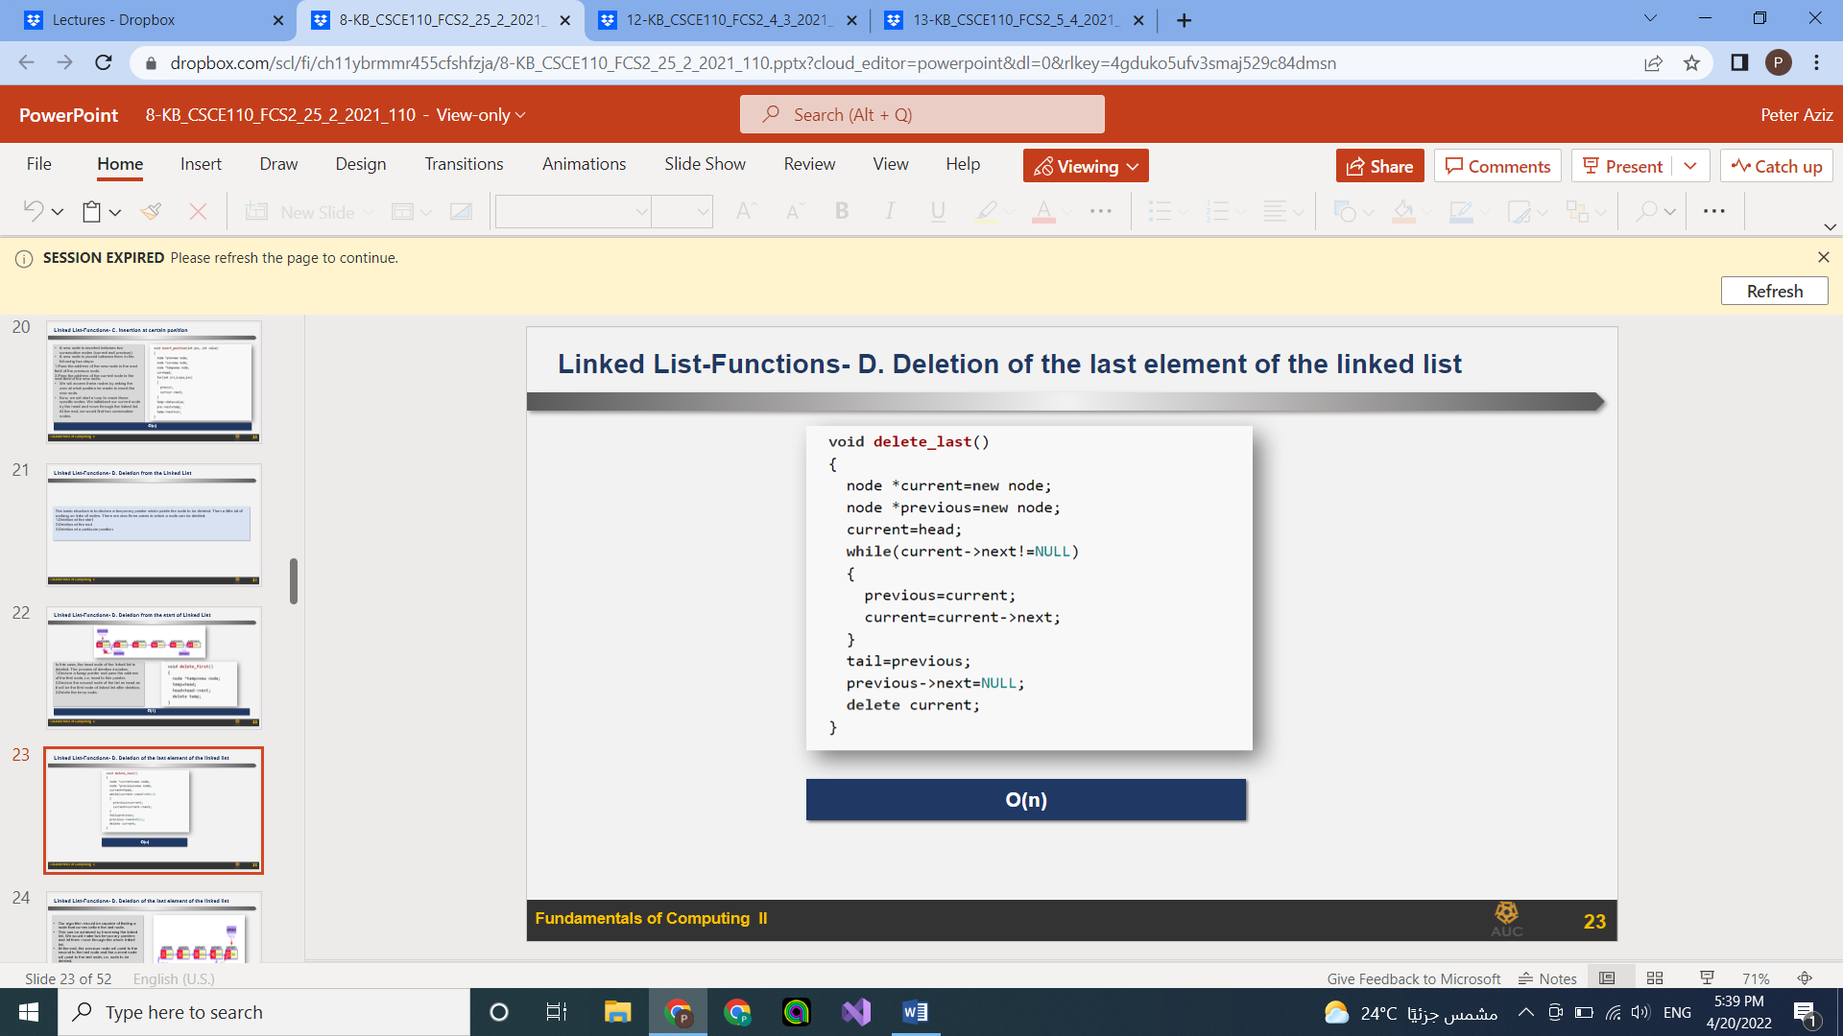

To delete from a certain location

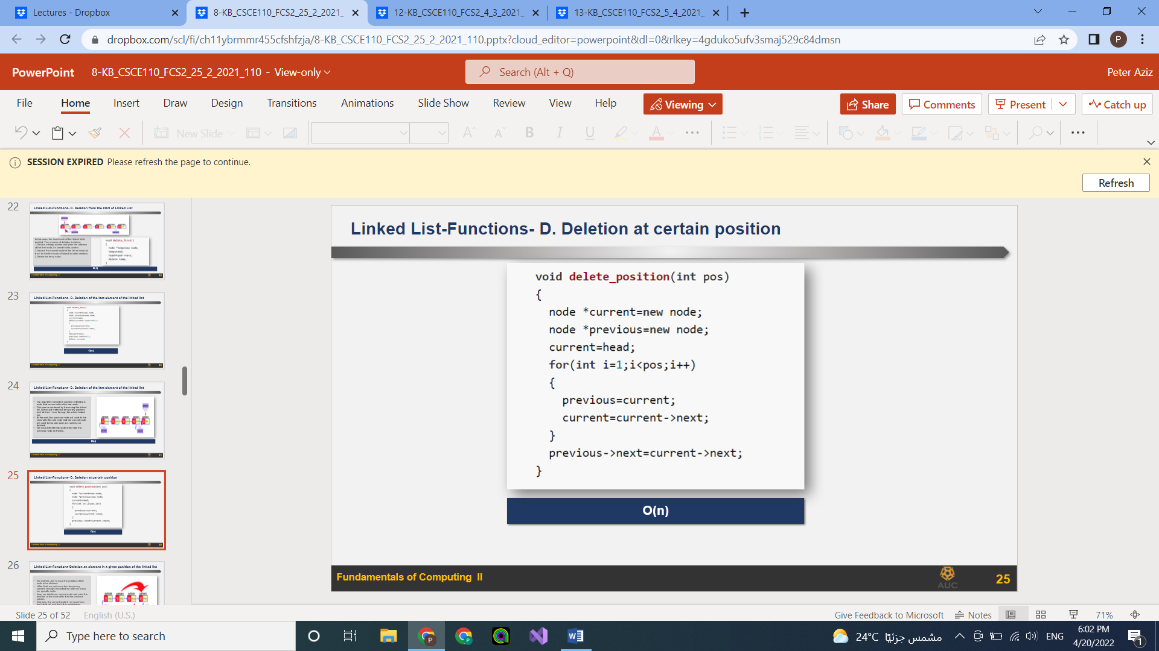

To search for an element in the list

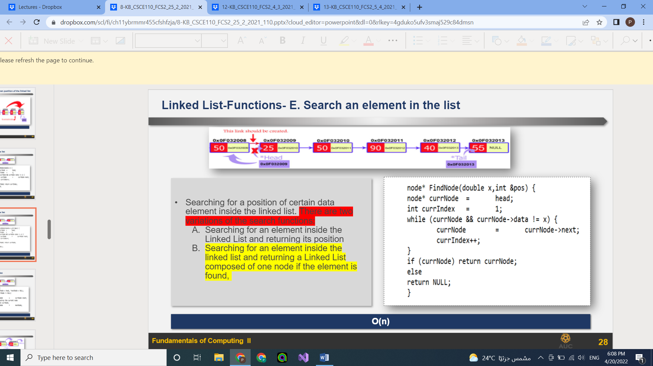

To destroy a linked list

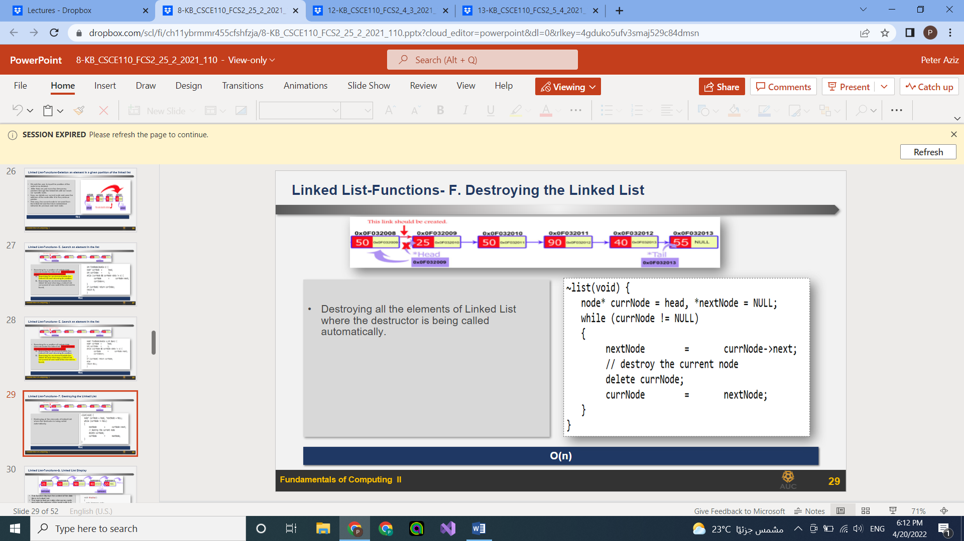

To display a linked list

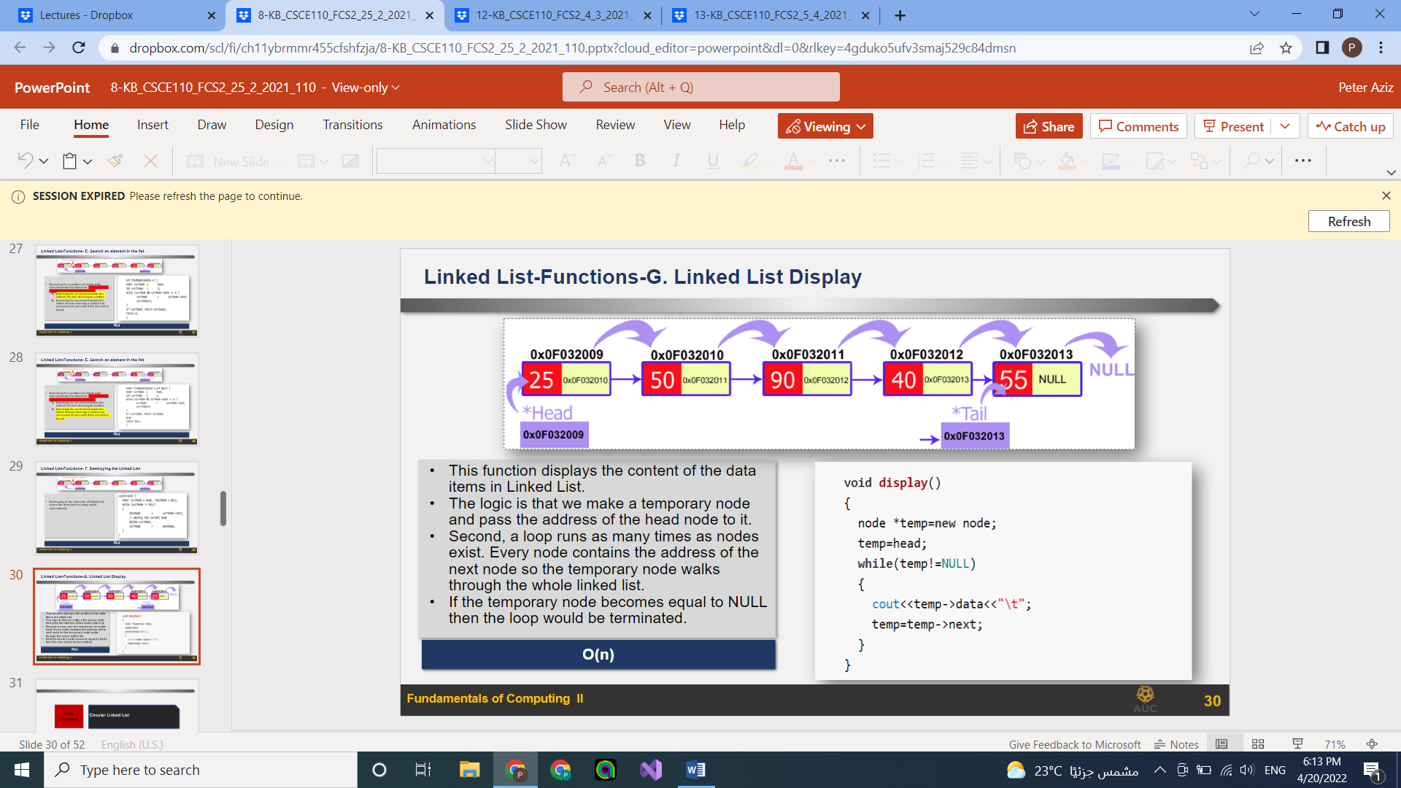

## Lecture 9:

Static variables: allocated once and even if they are used again they are not reinitialized

The have a scope till the need of the program

### Lecture 10:

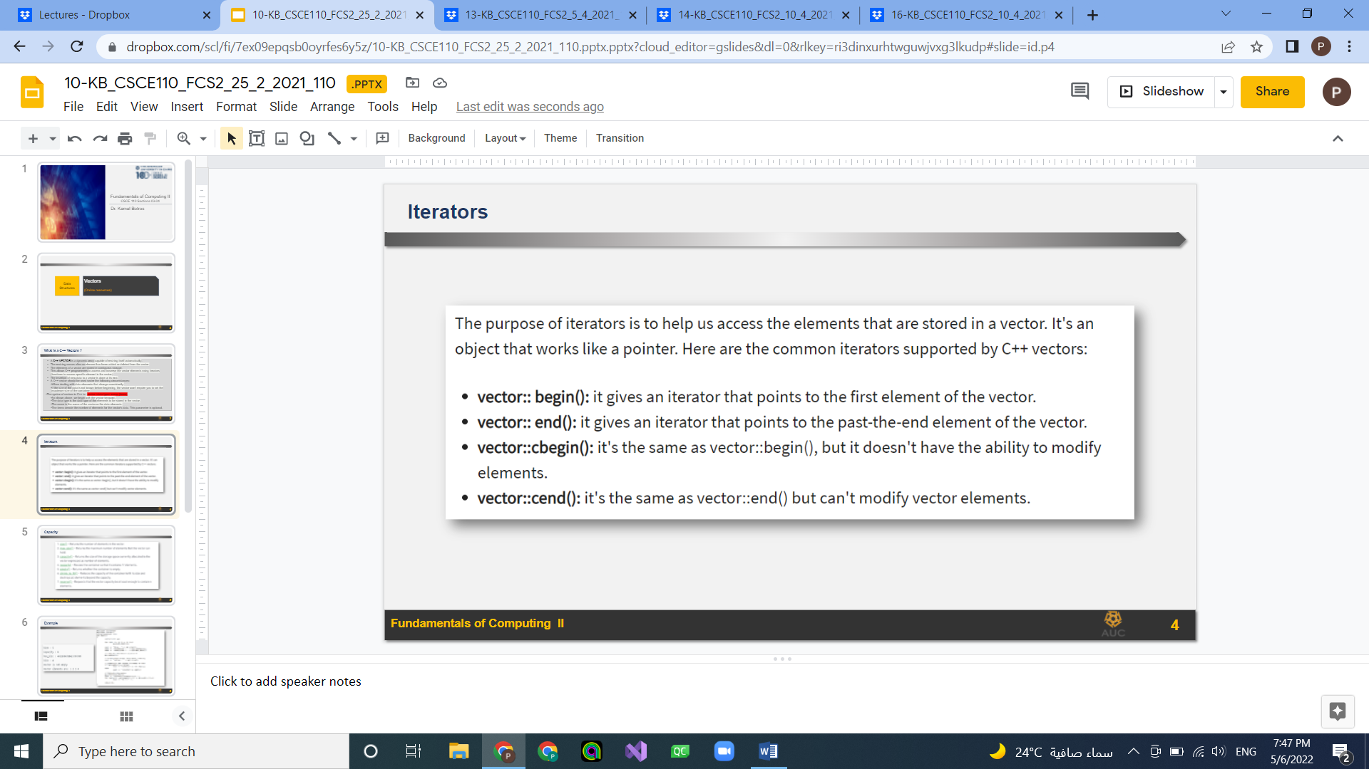

## 

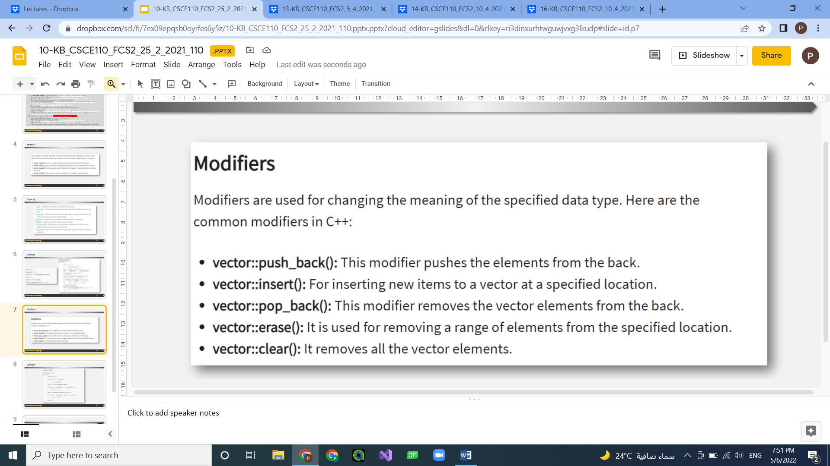

## Lecture 12:

Binary search tree: a tree with a maximum of two children and all the values to the right of any value are larger and to the left smaller

Node: actual data

Edge: line connecting data, number = number of nodes-1

Root node: first node in the tree

Siblings: nodes that belong to the same parent

Internal node: node with at least one child

Degree: total number of children of a node

Level: levels in the tree and root node is at level 0

Height: total number of edges from the root node to a particular node

Height of the tree: height of root node

Depth of a node: largest number of edges from a root to a particular node

Path: sequence of nodes and edges between two node

To create linked list tree:

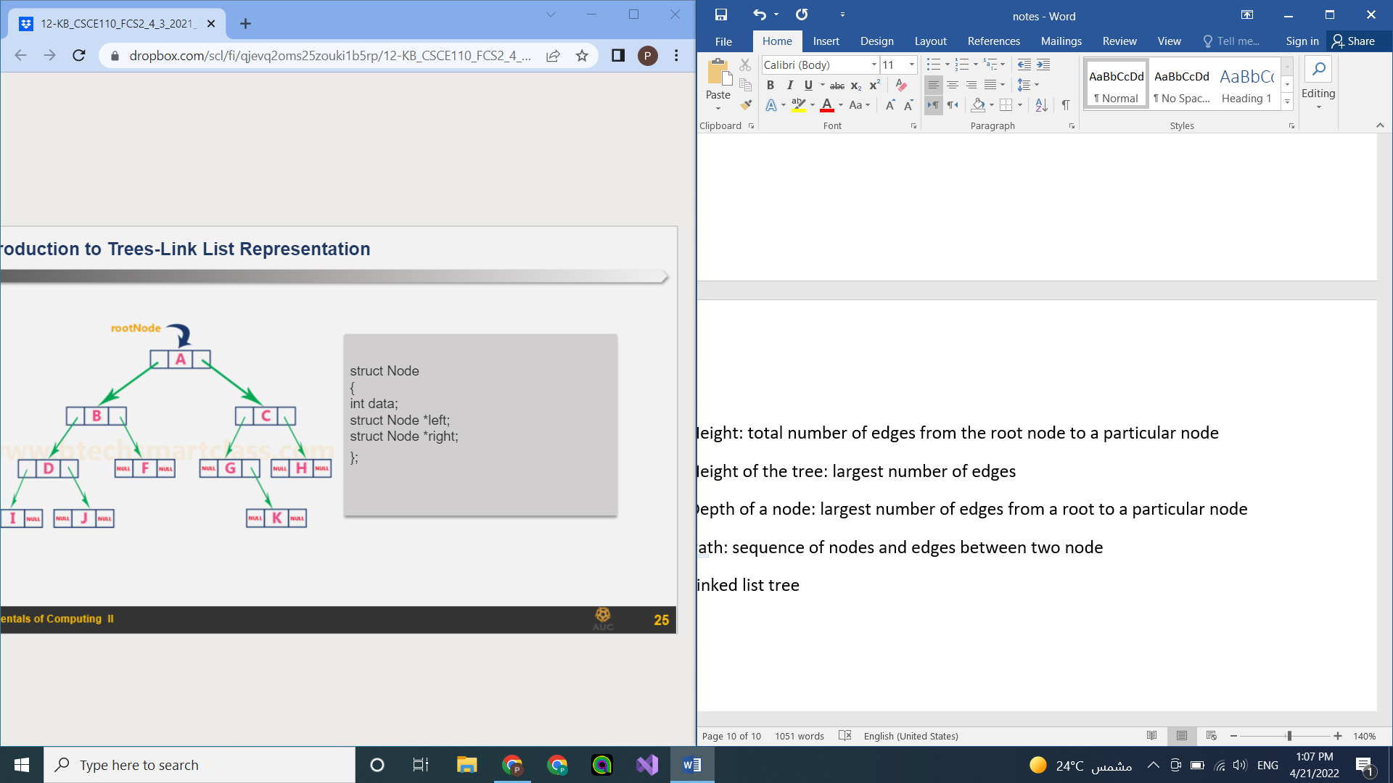

To traverse a binary search tree all cases O(n)

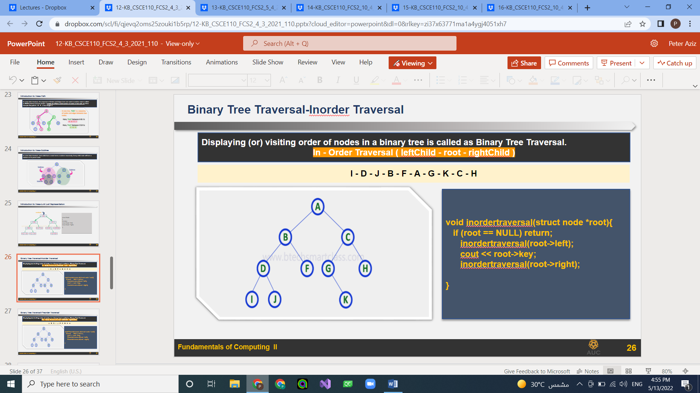

Binary search tree: **search** average O(log n) worst O(n)

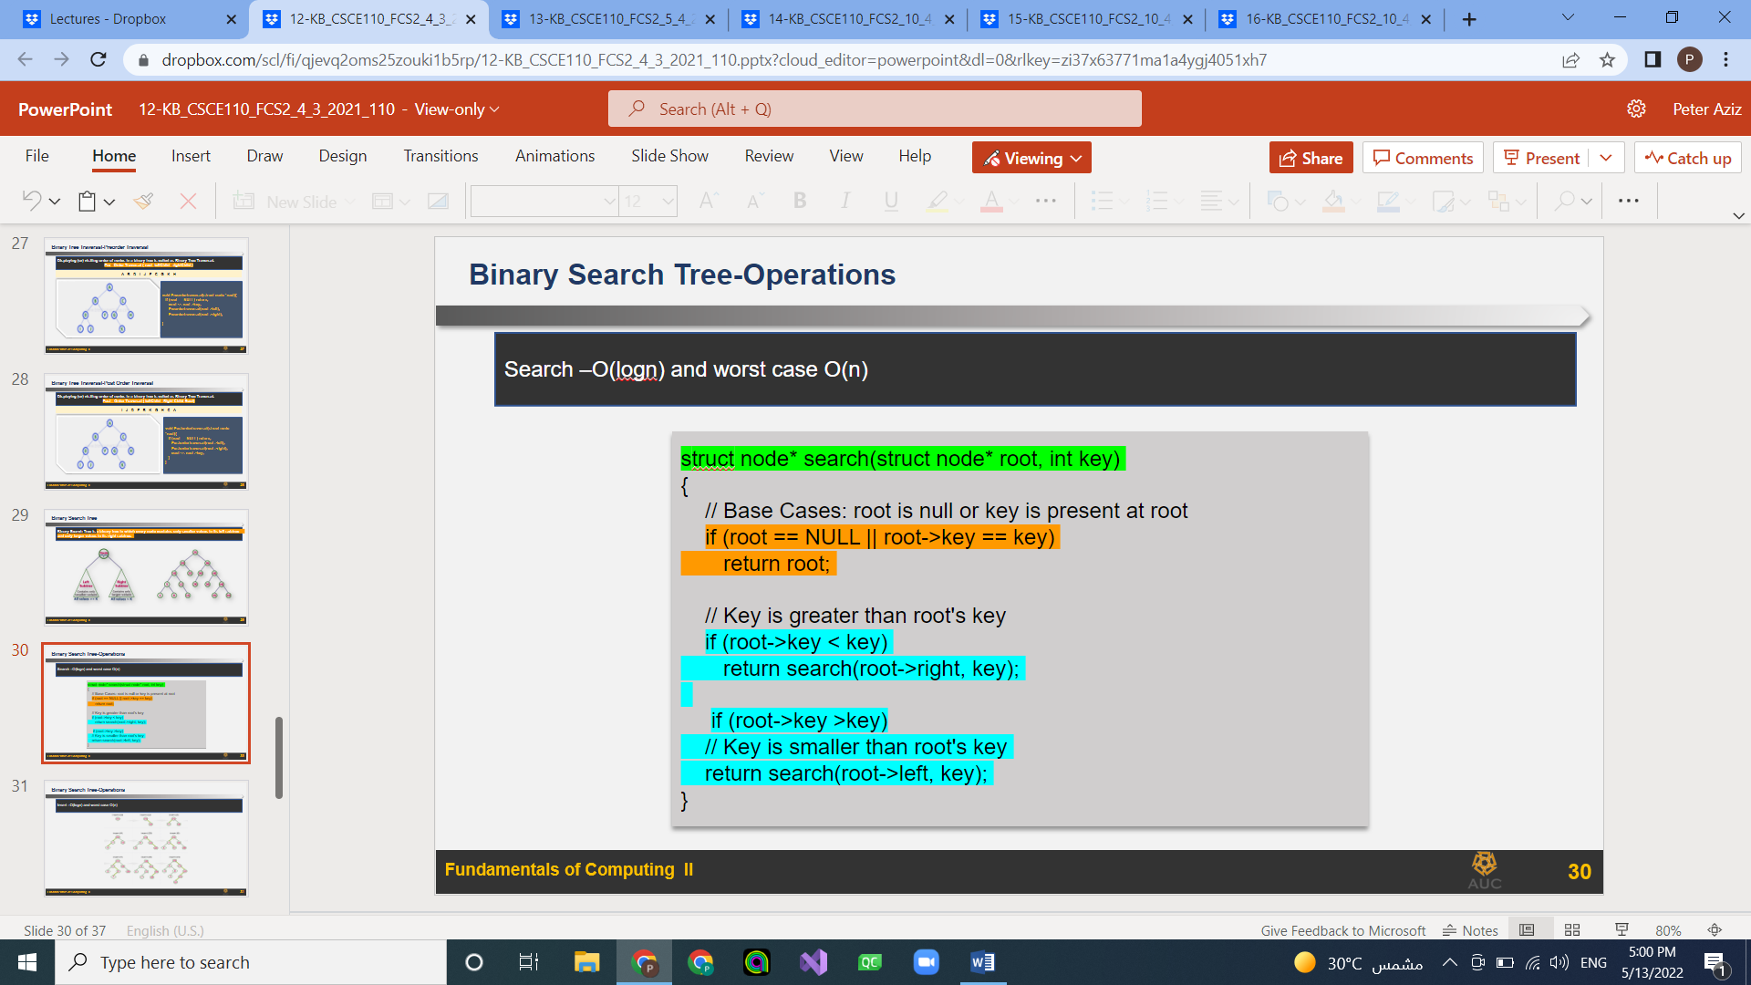

Binary search tree: **insert** average O(log n) worst O(n)

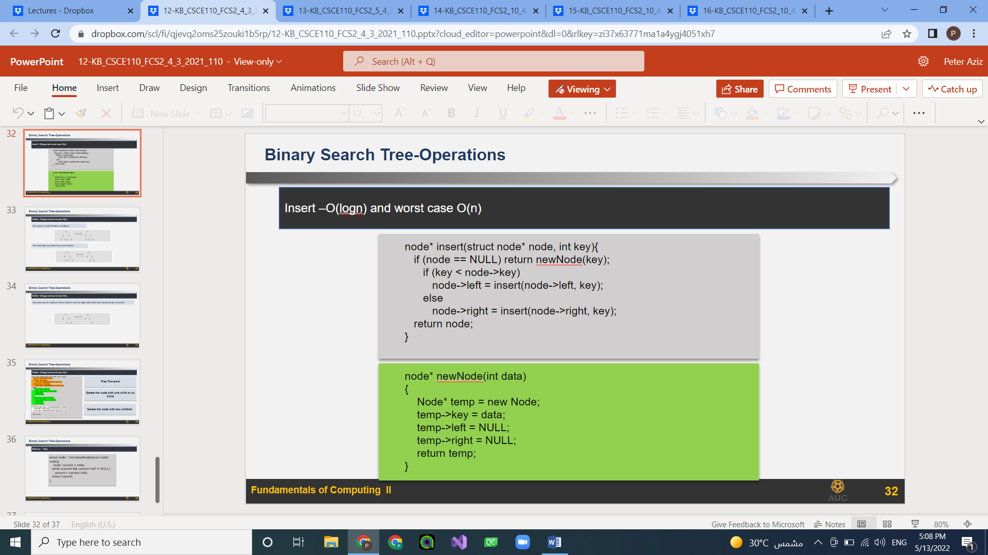

Binary search tree: **delete** average O(log n) worst O(n)

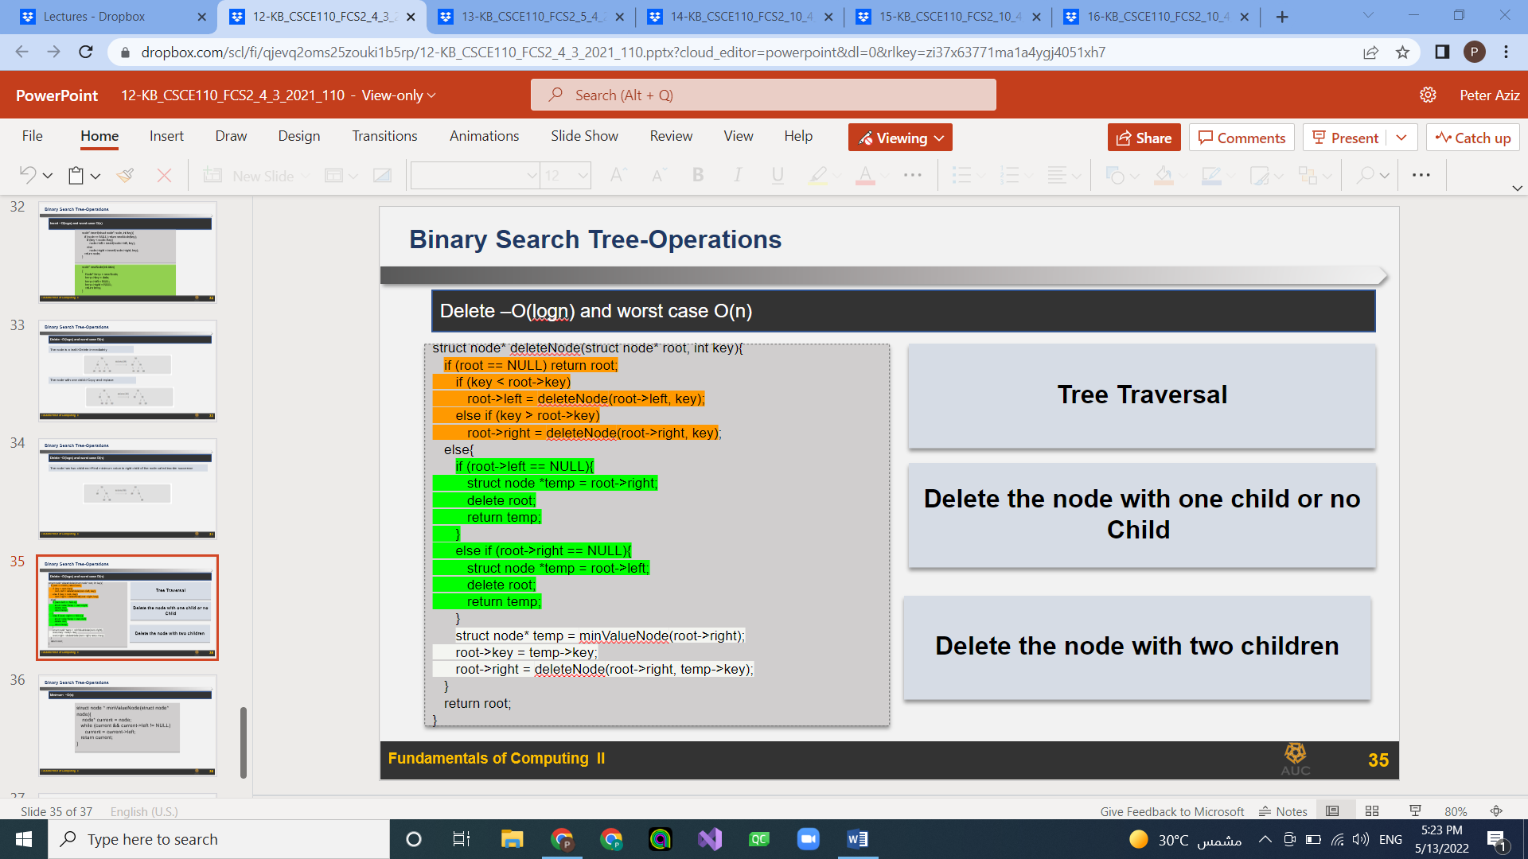

## Lecture 13:

A Graph is a non-linear data structure consisting of nodes and edges.

An undirected graph has no direction between nodes

The maximum number of edges in an undirected graph without a loop is n(n-1)/2​

Directed graphs have a direction (arrow) between nodes

A multigraph is an undirected graph in which multiple edges

A loop is an edge (directed or undirected) that connects the vertex to itself

A weighted graph has a cost to move between nodes

A complete graph is where all the edges that could exist are present. ​

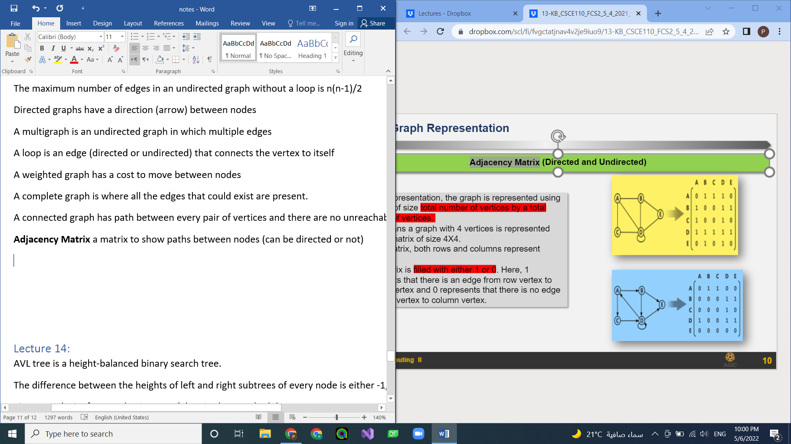A connected graph has path between every pair of vertices and there are no unreachable vertices.

​**Adjacency Matrix** a matrix to show paths between nodes (can be directed or not)

It is created using the total number of vertices by a total number of vertices. ​

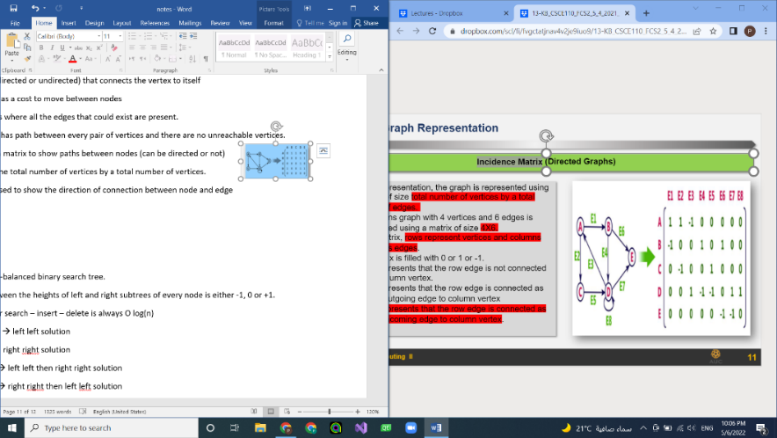**Incidence Matrix** used to show the direction of connection between node and edge

Is created using the number of nodes and the number of edges

**Adjacency list** a list that shows every vertex and its adjacent vertices

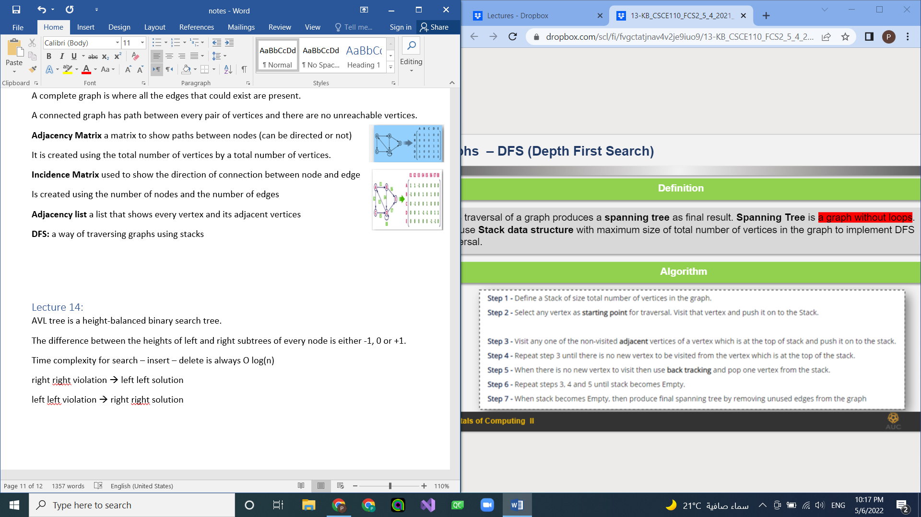**DFS:** a way of traversing graphs using stacks that produces a spanning tree (graph without loops)

**BFS:** a way of traversing graphs using queues that produces a spanning tree (graph without loops)



**Shortest path algorithm:**

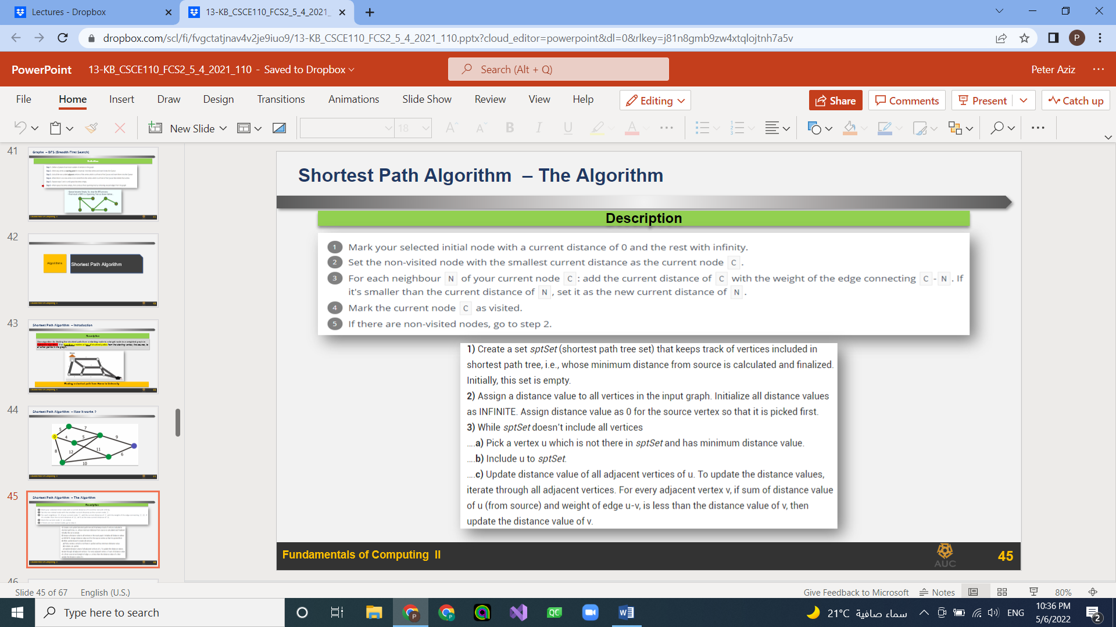

## Lecture 14:

AVL tree is a height-balanced binary search tree.

The difference between the heights of left and right subtrees of every node is either -1, 0 or +1. ​

Time complexity for search – insert – delete is always O log(n)

right right violation 🡪 left solution

left left violation 🡪 right solution

left right violation 🡪 left left then right solution

right left violation 🡪 right right then left solution

To insert:

Insert node as a leave

Check balance

If balanced go to next operation

If not, balance then go to next operation

Deletion in an AVL tree

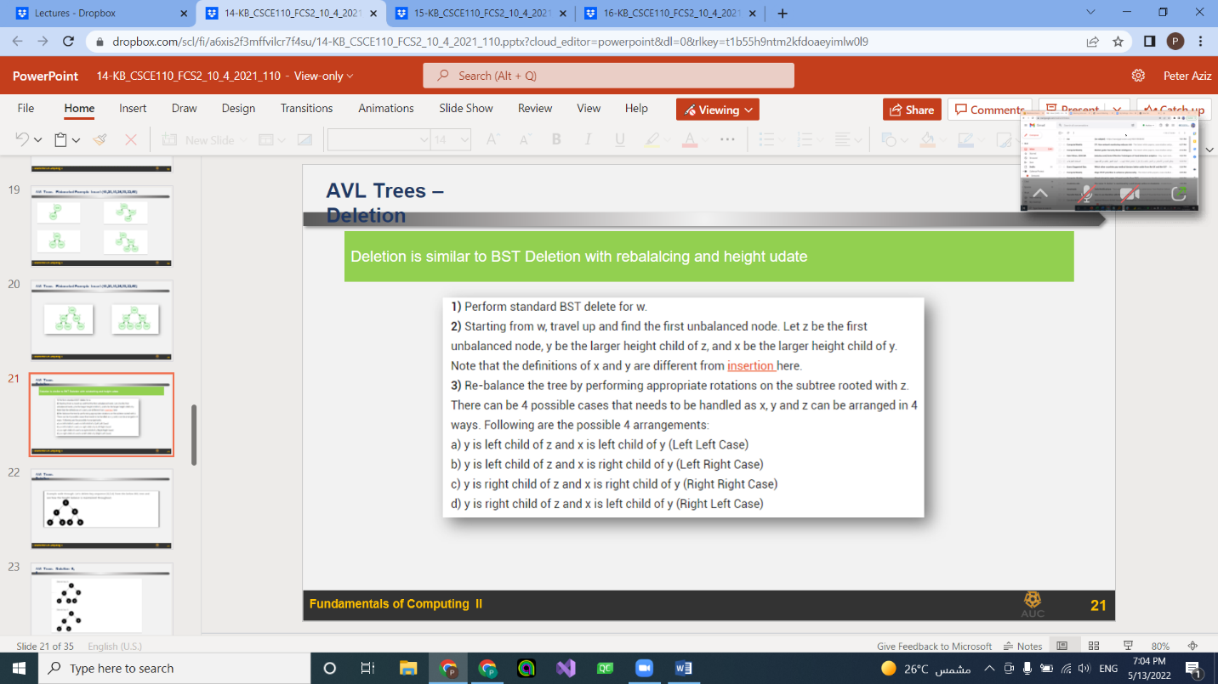

## Lecture 15:

Red black trees: binary search trees with colors

Root must be black

Cannot have two consecutive red trees

In all paths the number of black nodes should be equal

Any node is inserted with a red color

All leaves are black even leaves that does not exist (NULL nodes)

Insertion – deletion – search have a complexity of O(log n)

To insert in a RBT

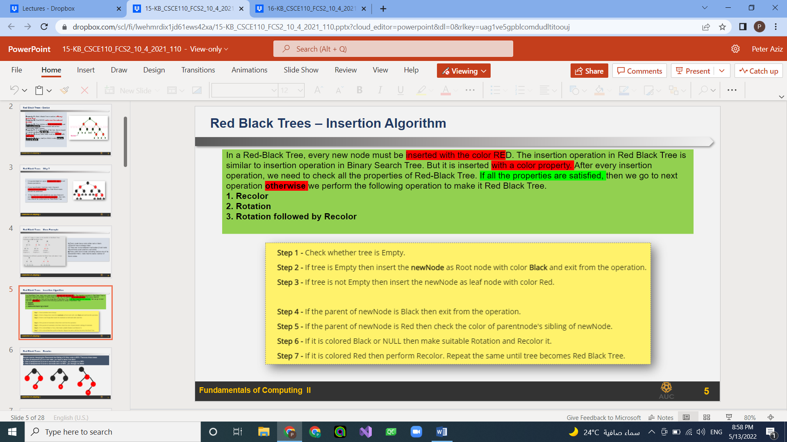

If uncle is red 🡪recolor (parent – grandparent – uncle)

If uncle is black 🡪 rotate then recolor (parent – grandparent – uncle)

## Lecture 16:

Full binary tree: all leaves have the same level and all internal nodes have two children

Complete binary tree: almost full and all leaves in the last level are in the left most position

Array representation of a tree to save memory

* left child of tree.nodes[index] = tree.nodes[2*index]​
* right child of tree.nodes[index] = tree.nodes[2*index+1] ​
* parent node of tree.nodes[index] = tree.nodes[(index)/2]        (int division-truncate) ​

heap: complete binary tree where value stored is always more than or equal value in children nodes

max heap: root has largest value min heap: root has smallest value

**Insertion: O(n*log(n))**

1. Insert a new-node as a leaf node
2. Compare new-node to parent node
3. If new-node > parent, swap
4. Repeat step 2 and 3

**Deletion: O(n*log(n))**

1. Swap root with last node in the heap
2. Delete last node
3. Compare root and left child
4. If root < left, compare left with right else go to step 6
5. If left < right, swap root with left
6. If root > left child, compare root and right child
7. If root < right child, swap root and right else stop
8. Repeat until root node is in correct position

**Heapify O (n*log n)**

**Heapify “bottom up”: O(n)**

1. Add numbers to a binary tree
2. Start from the right most node and compare to parent node to adjust position

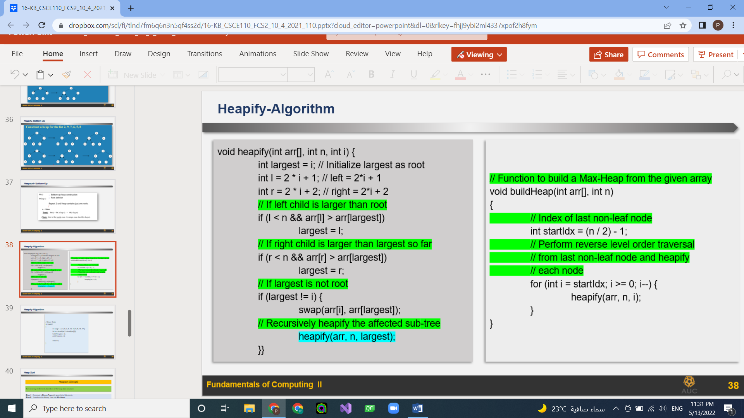

**Heap sort O(n*log n)**

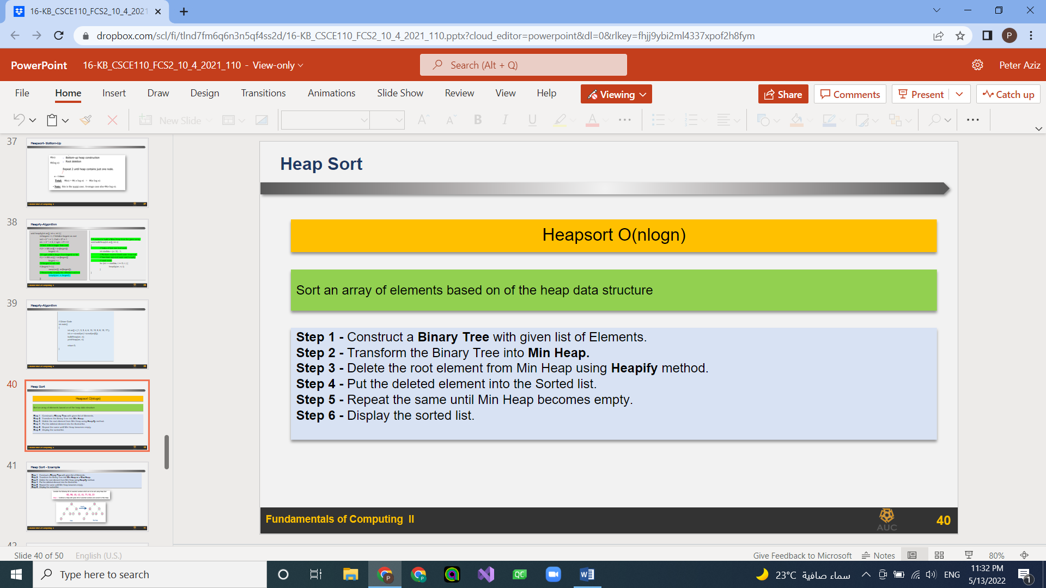

**Priority queue** Normal heap insert and delete

For insert and delete from heap, it is O(log n) for one element. For all, O(nlogn)​